TEAM ID :PNT2022TDMID40586 TEAM LEADER : C.V.GOWSIKHA TEAM MEMBER 1 : K.TAMILARASAN

TEAM MEMBER 2 : G.ARULRAJ

TEAM MEMBER 3 : S.KUMARESAN

TEAM SIZE : 4

MENTOR : R.ARULAARUMUGAM

IBM CLOUD SERVICES

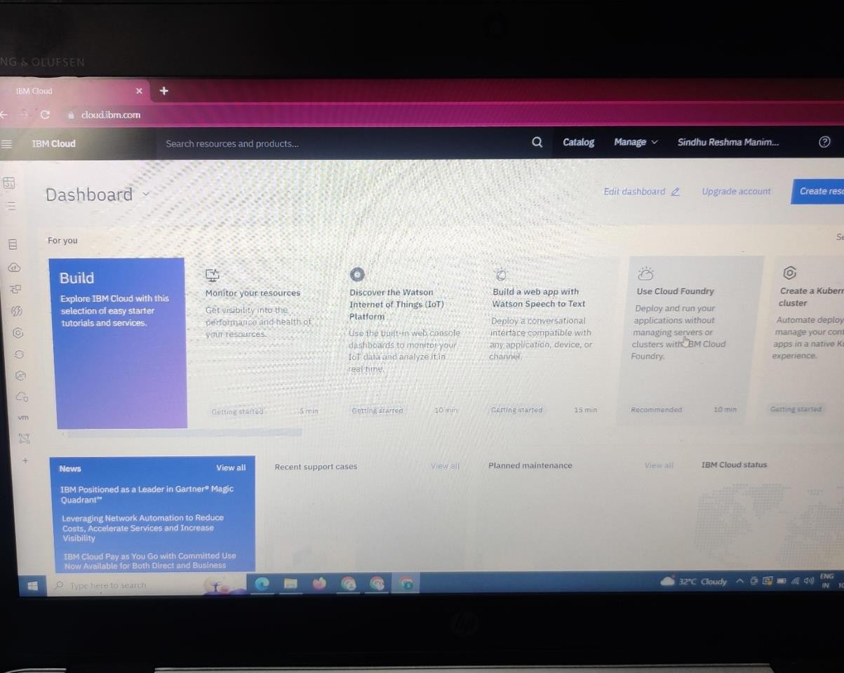

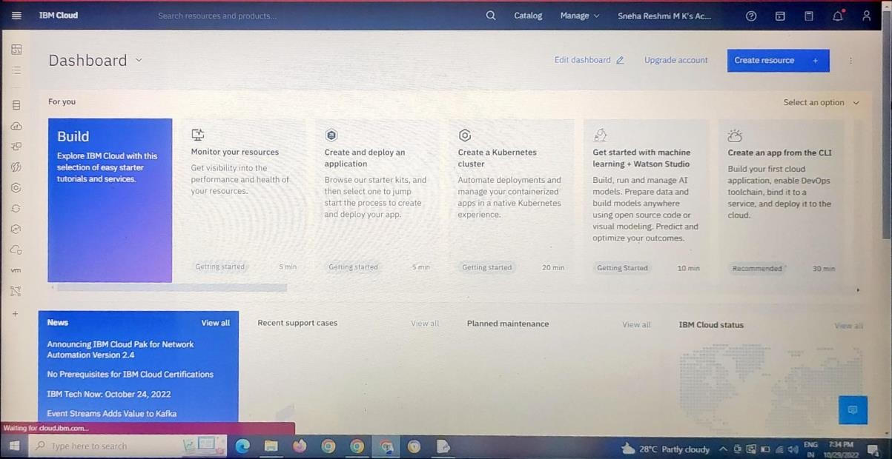

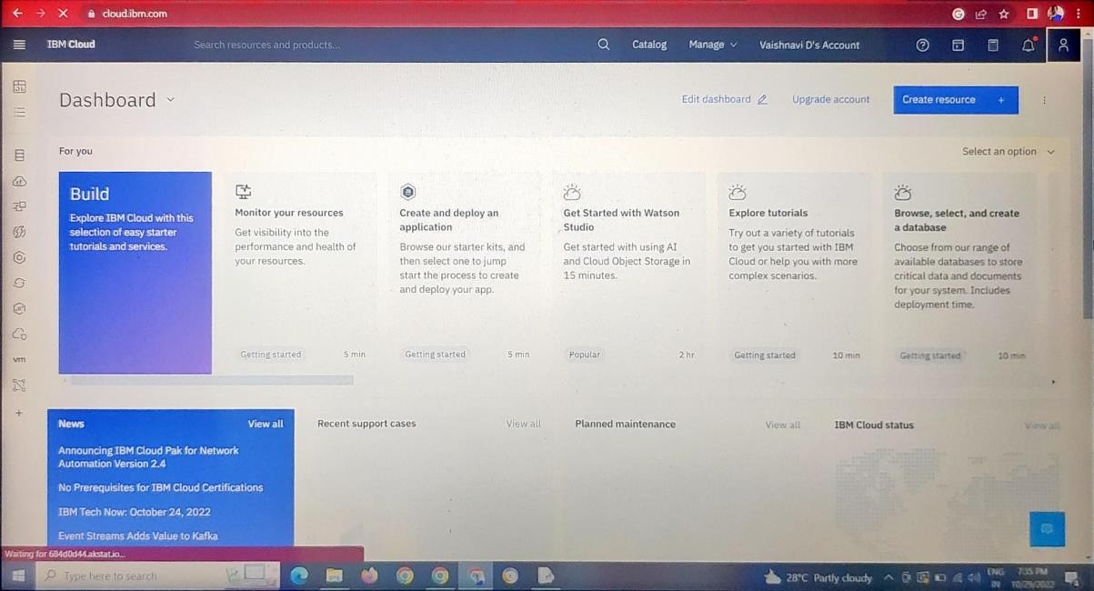

I

